Project Name | RK-HEALTH
Date | 3 July 2026
Team ID

Phase 2: Technology Stack & Technical Architecture

1. Architecture Diagram
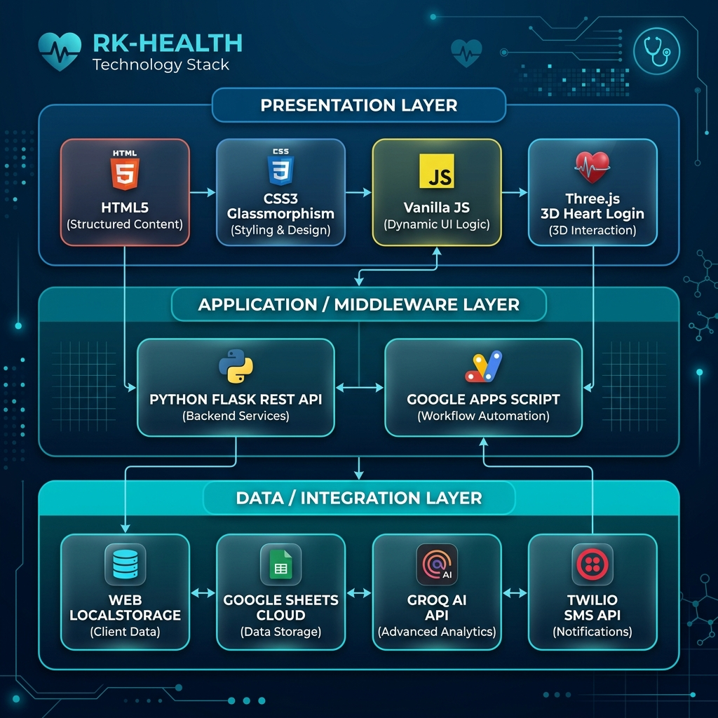
Figure 1: Layered Technical Architecture of RK-HEALTH System
2. Components & Technologies mapping
S.No | Component / Module | Functional Role | Tech Stack used
1 | Presentation Layer UI | Responsive glassmorphism patient dashboard | HTML5, CSS3 Variables, ES6+ JS, Font Awesome 6
2 | 3D Scene Login | Interactive 3D login screen | Three.js r128 (WebGL renderer)
3 | Application State Logic | Client-side CRUD logic and role controls | Vanilla JS, state variables
4 | AI Chatbot Triage | Processes queries and maps symptoms to doctors | Vanilla JS rules + Groq Cloud LLaMA 3.3-70B API
5 | Local Database | Offline-first JSON data logger | Browser localStorage API
6 | Cloud Database | Live mode persistent storage | Google Sheets (Sheets DB)
7 | Database Sync API | REST API proxy to write to Sheets | Google Apps Script (GAS) Web App endpoint
8 | Middleware server | Enables Groq and Twilio API routing and handles CORS | Python 3.13, Flask REST Server, Gunicorn, CORS
9 | AI Summary Engine | Generates checkup summaries | Groq API LLaMA 3.3-70B-versatile model
10 | SMS Alerts | Triggers SMS reminders for medications | Twilio Messaging REST API
11 | Calendar sync | Creates calendar event invite links | Google Calendar URL Generator API
12 | Frontend Hosting | Serves frontend static build via SSL/CDN | GitHub Pages
13 | Backend Hosting | Hosts Python Flask Web Server | Render.com Cloud Environment
14 | Package managers | Installs packages and controls environments | NPM (Javascript), Pip / virtualenv (Python)

3. Application Characteristics
S.No | Characteristic Area | RK-HEALTH Implementation Details
1 | Open-Source Frameworks | Vanilla frontend (no JS framework overhead), Flask for backend routing, Three.js for interactive 3D WebGL scenes.
2 | Security Protocols | Client role-based security layers. Secure deployment configuration with API key separation. Production tokens in backend environment.
3 | Scalable Architecture | Stateless frontend static files cached on GitHub Pages CDN. Horizontal scaling support in Flask server threads.
4 | Availability & Failover | Offline-capable operation fallback. Uptime SLA (99.9%) on CDN hosting. Graceful degradation in API modules.
5 | Performance & Load time | Sub-2s page load, Groq AI inference replies in <1.5s. Hardware accelerated 3D graphics on browser GPU.

References:
• Groq Cloud API documentation: https://console.groq.com/docs/quickstart
• Twilio SMS API documentation: https://www.twilio.com/docs/sms
• Google Apps Script Documentation: https://developers.google.com/apps-script
• Three.js documentation: https://threejs.org/docs/

